Running title: {Running title is an abbreviated form of the main title, usually cited at the top of each published page or left-hand text pages.}

Article type: {Original Article, Research Article, Research, or just Article}

{Title of the Paper – Font: Times New Roman Size:16}

Author1ª, Author2^{b} (Font: Times New Roman, Size: 12)

ªAffiliation1, Address, City and Country (Font: Times New Roman, Size: 11)
^{b}Affiliation2, Address, City and Country (Font: Times New Roman, Size: 11)

(Received xxxx xx, xxxx; Accepted xxxx xx, xxxx)

ABSTRACT: All manuscripts must include a maximum of 300 words abstract, along with a total of 4 to 5 keywords in italics one line below the abstract. Avoid References and using the complete statistical results. A concise and factual abstract is required which should briefly state;
Purpose of the research: Goal of the study or why the study is being conducted. Methodology: Research method applied to interpret. Findings: Main results or findings of the study. Implications: Major implications of the study. Originality: Prove novelty or originality of the study.
(Font: Times New Roman, Size: 11)
Keywords: Employee Engagement, Organisational Culture, Leadership, HR Policies, and Organisational Effectiveness.
(Font: Times New Roman, Size: 11, Italic)

JEL Classifications: {https://cran.r-project.org/web/classifications/JEL.html }

Manuscript Contents
Manuscript should contain the following section in the given order;
(1) Introduction: The introduction should contain the background of the study, the research problem, research questions, research objectives, and the significance of the study.
(2) Literature Review: The literature review should contain the theoretical framework, which should have various theories, which are relevant to the area of study. It should also have empirical framework and the conceptual framework of the given study.
(3) Methodology: The methodology section should contain information concerning the manner in which collection and analysis of data took place. Some of the main aspects of the methodology section include the research design, research population, sample size and sampling technique, data collection methods, instruments for data collection, data analysis and ethical issues when the research is being carried out.
(4) Analysis / Discussion: This section should contain the findings of the research based on the data collected from the field through the use of the data collection tools. The results should be presented in tables, graphs and charts. This is to ensure that the people interested in the findings of the study can easily interpret them.
The discussion section compares the results of the study with previous studies, which have been carried out by the other scholars.
(5) Conclusion: This is a summary of the research. It should give a summary of the findings of the study based on the actual data, which was collected and which was also analyzed.
(6) Author Contributions
(7) Financial Support
(8) Acknowledgements: The section will mainly contain information concerning the people who helped the researcher during the research process.
(9) Conflict of Interest: Authors must acknowledge and declare any sources of funding and potential conflicting interest, such as receiving funds or fees by, or holding stocks and shares in, an organization that may profit or loss through publication of their paper. Declaring a competing interest will not lead to automatic rejection of the paper, but we would like to be made aware of it.
(10) References: This should be a list of all the references, which were used in the given research. Should be in alphabetical order.
(11) Figure(s) Figures and tables should be kept to a necessary minimum, and their information should not be duplicated in the text. The position of figures and tables should be indicated in the manuscript. Colour images should be at least 300 DPI in JPEG, TIFF or BMP format. Illustrations should be designed to fit the journal page with a maximum plate size 254×203 mm, have an additional white border. Larger illustrations will be printed at the discretion of the Editor. Reduction or cropping may be necessary to conserve space. The best results can be obtained from the original artwork and original photographs. A short detailed legend (maximum, 60 words long) should be provided for each figure. Legends for the illustrations should be typed double spaced. Colour illustrations cannot be reproduced in colour unless the cost is subsidized by the author. Authors will receive notice of the cost of colour reproduction as soon as after acceptance as possible. The corresponding author must sign a written agreement to cover the estimated costs before the production of colour figures will be undertaken. In case of using a non-original figure, the author is responsible for the copyright notice of the original work. Also, proper citation is needed.
(12) Table(s): Tables should be typed on separate sheets and be numbered. Each table must include appropriate headings and Footnotes.
Citation Style:
APA citation style should be followed for referencing according to the publication manual of the American Psychological Association APA, 2010, 6th edition. Please ensure that every reference cited in the text is also present in the reference list (and vice versa). Avoid citation in the abstract. Unpublished results and personal communications should not be in the reference list, but may be mentioned in the text. Citation of a reference as 'in press' implies that the item has been accepted for publication.
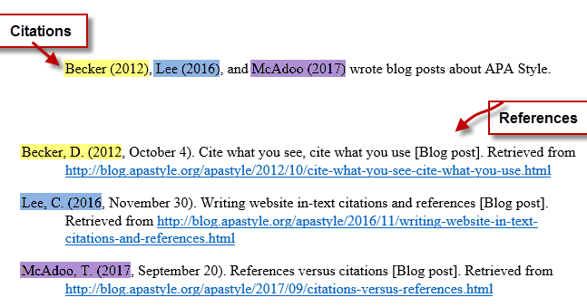

References
Author(s) should follow the 6th edition APA style in referencing. Please visit www.apastyle.org to learn more about APA style. References should be arranged first alphabetically and then further sorted chronologically if necessary. Use the following format for References

Book
[1] De Vaus, D. A. (2014). Surveys in social research. Sydney, Australia: Allen & Unwin.

Book Chapter
[1] McKenzie, H., Boughton, M., Hayes, L., & Forsyth, S. (2008). Explaining the complexities and value of nursing practice and knowledge. In I. Morley & M. Crouch (Eds.), Knowledge as value: Illumination through critical prisms (pp. 209-224). Amsterdam, Netherlands: Rodopi.

Journal Article
[1] Cheung, J. M. Y., Bartlett, D. J., Armour, C. L., Laba, T. L., & Saini, B. (2018). To drug or not to drug: A qualitative study of patients’ decision-making processes for managing insomnia. Behavioral Sleep Medicine, 16(1), 1-26. doi:10.1080/15402002.2016.1163702

Webpage with an Author
[1] HealthTimes. (2015). The future of aged care nursing in Australia. Retrieved from https://healthtimes.com.au/hub/aged-care/2/news/nc1/the-future-of-aged-care-nursing-in-australia/495/

Webpage with no Author
[1] $250m funding boost for malaria vaccine. (2003). Retrieved from https://www.abc.net.au/news/2003-09-22/250m-funding-boost-for-malaria-vaccine/1482220

Newspaper Article
[1] Fellner, C. (2019, April 7). Time bomb: Two new cases as NSW faces worst measles outbreak in years. The Sydney Morning Herald. Retrieved from https://www.smh.com.au

Government Publication
[1] Australian Institute of Health and Welfare. (2018). Physical activity across the life stages. Canberra, Australia: Author.
[2] Australian Institute of Health and Welfare. (2018). Physical activity across the life stages. Retrieved from https://www.aihw.gov.au/reports/physical-activity/physical-activity-across-the-life-stages/contents/table-of-contents

Company and Industry Reports
[1] Vuong, B. (2018, November). IBISWorld industry report OD5381. Coffee shops in Australia. Retrieved from IBISWorld database.
***

